DESIGN TASK
P. VENKATA KISHORE
192412581
OBJECTIVE: 1. Propose an optimized fronthaul communication model.
OBJECTIVE:1: MATLAB CODE
clc;
clear;
close all;
N = 1000;
SNR = 0:2:20;
BER = zeros(size(SNR));
% Generate random bits
data = randi([0 1], N, 1);
% BPSK modulation
tx = 2*data - 1;
% Fronthaul communication
for k = 1:length(SNR)
snr = 10^(SNR(k)/10);
noise = randn(N,1) / sqrt(2*snr);
% Received signal
rx = tx + noise;
% Demodulation
data_rx = rx > 0;
% BER
BER(k) = sum(data ~= data_rx)/N;
End
% Plot BER
semilogy(SNR, BER, 'o-', 'LineWidth', 2);
grid on;
xlabel('SNR (dB)');
ylabel('BER');
title('Optimized Fronthaul Communication Model');

OUTPUT:
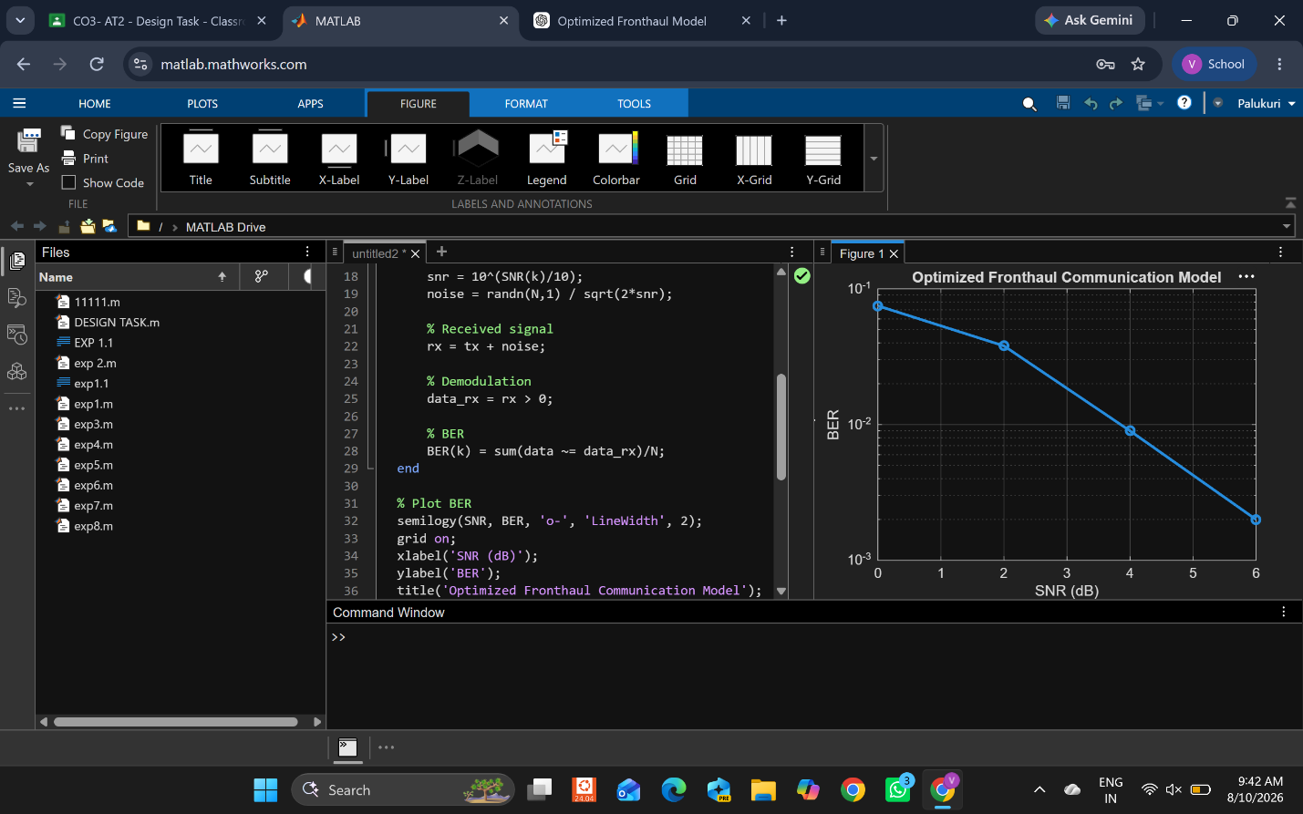

OBJECTIVE:2: Design a satellite-assisted communication model using Low Earth Orbit satellite for remote wireless coverage.
OBJECTIVE:2: MATLAB CODE
clc; clear; close all;
N=1000;
SNR=0:2:20;
data=randi([0 1],N,1);
tx=2*data-1;
for i=1:length(SNR)
noise=randn(N,1)/sqrt(2*10^(SNR(i)/10));
rx=tx+noise;
BER(i)=mean(data ~= (rx>0));
end
semilogy(SNR,BER,'o-','LineWidth',2);
grid on;
xlabel('SNR (dB)');
ylabel('BER');
title('LEO Satellite Assisted Communication');

OUTPUT:

